Video – 4(How can we do the integration in Salesforce with other systems ?):

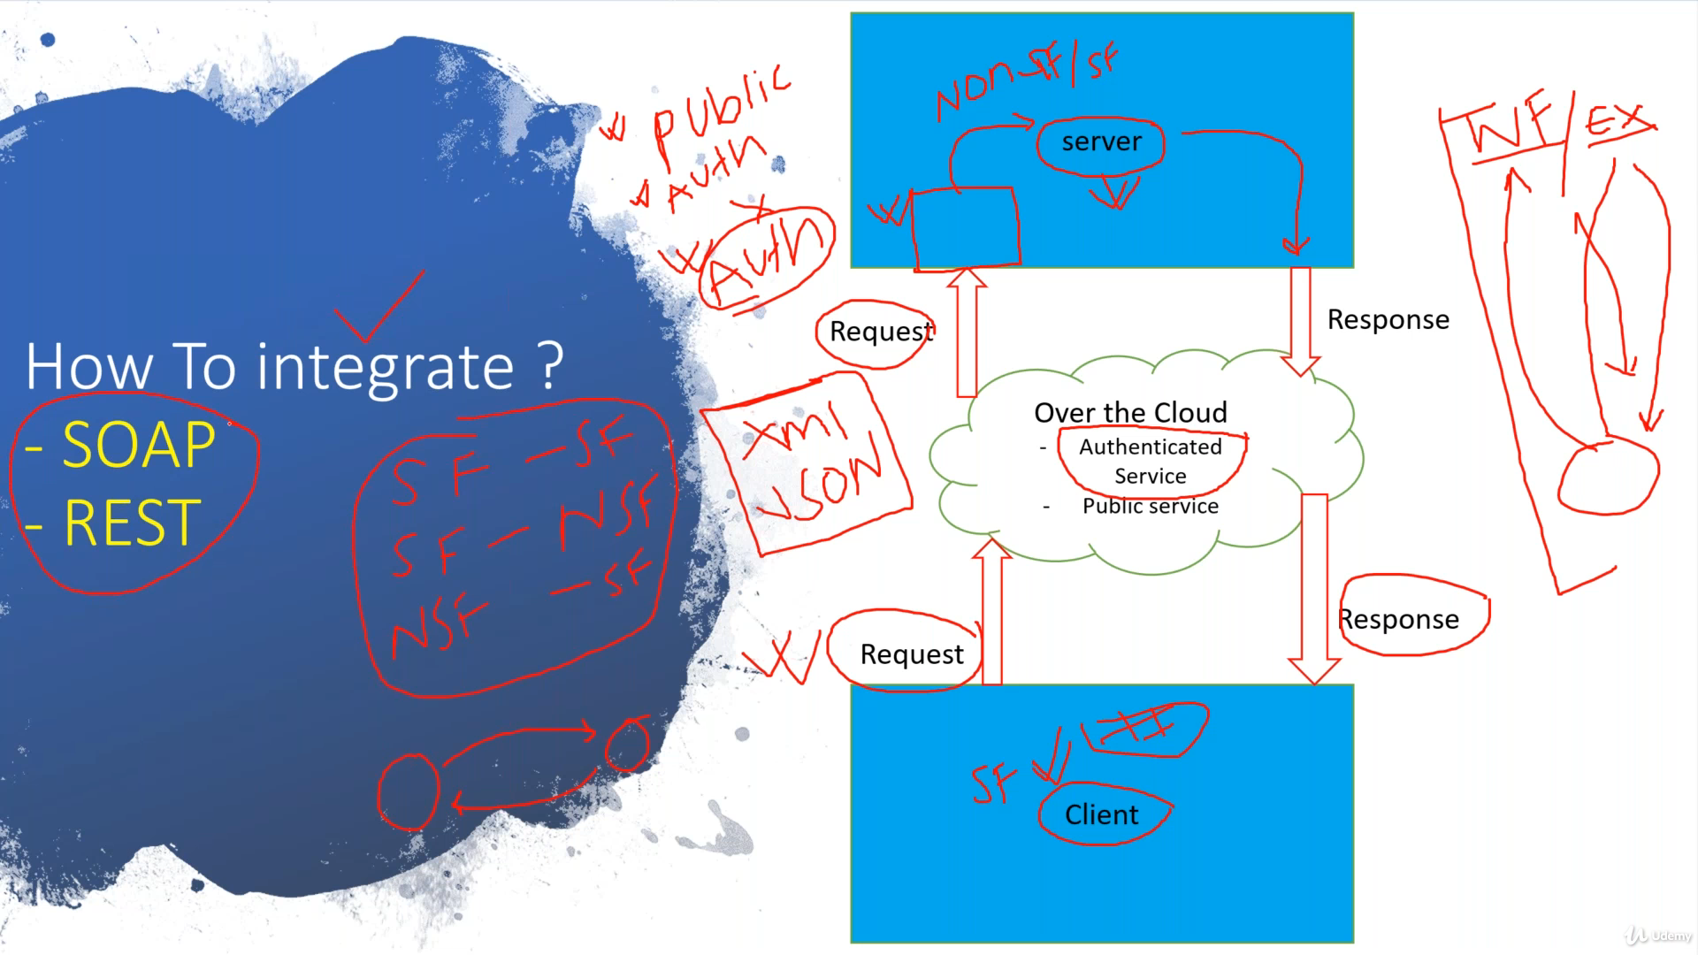

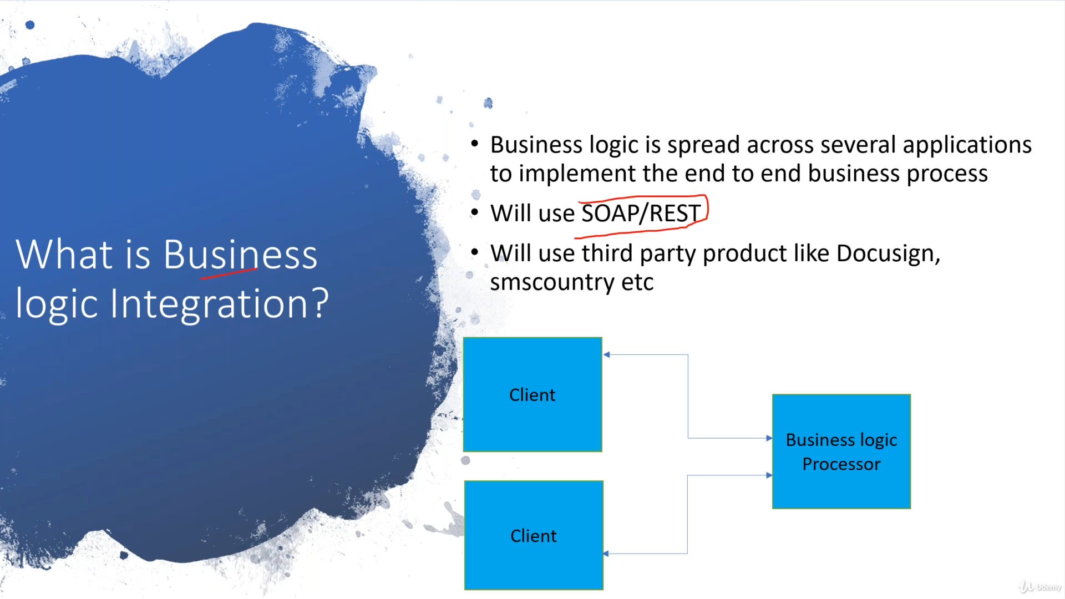

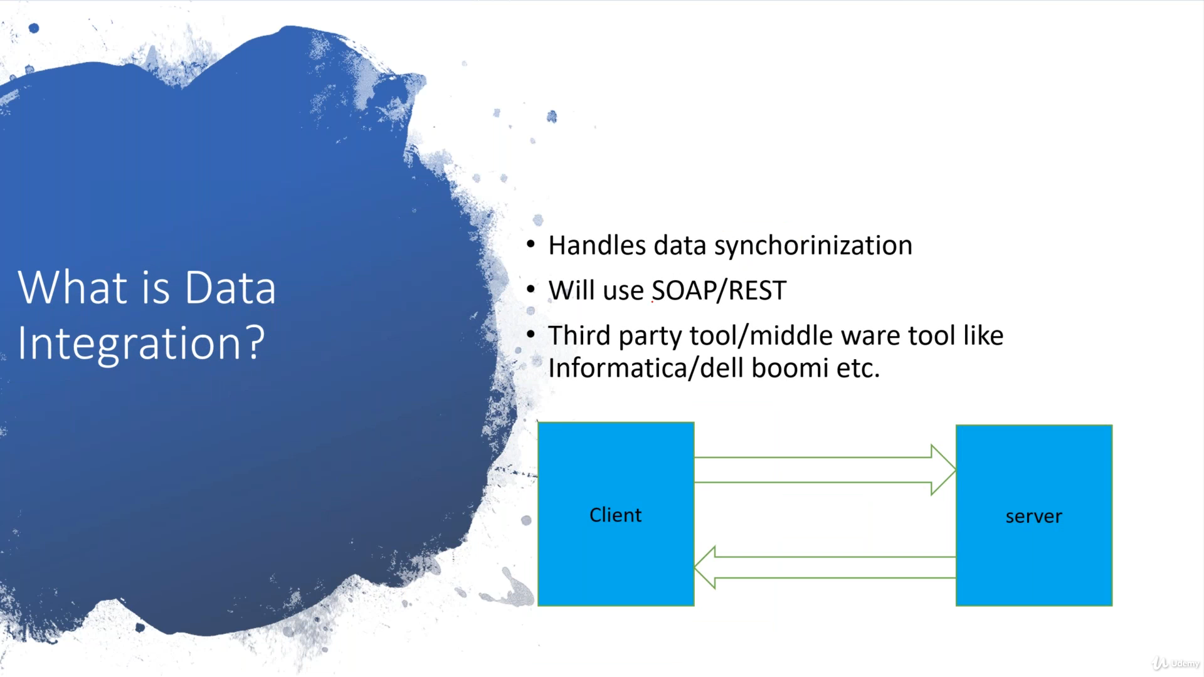

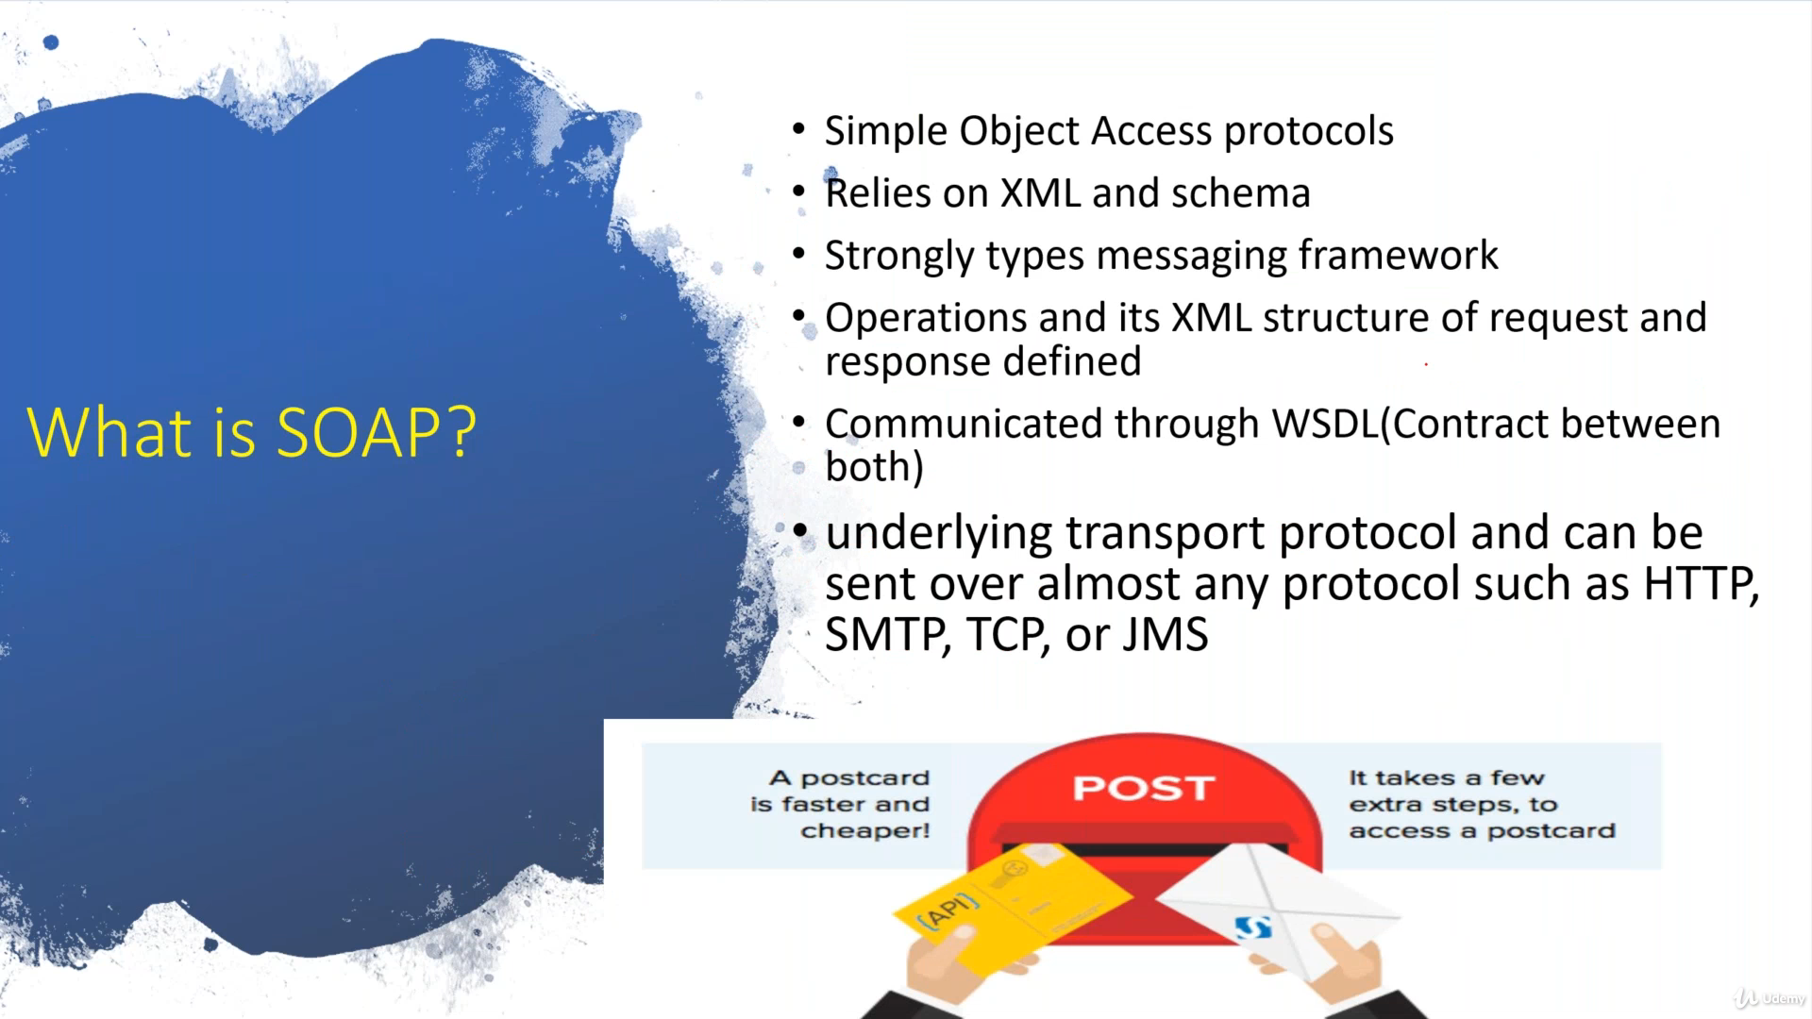

Video – 22(Overview of Connected App in Salesforce):

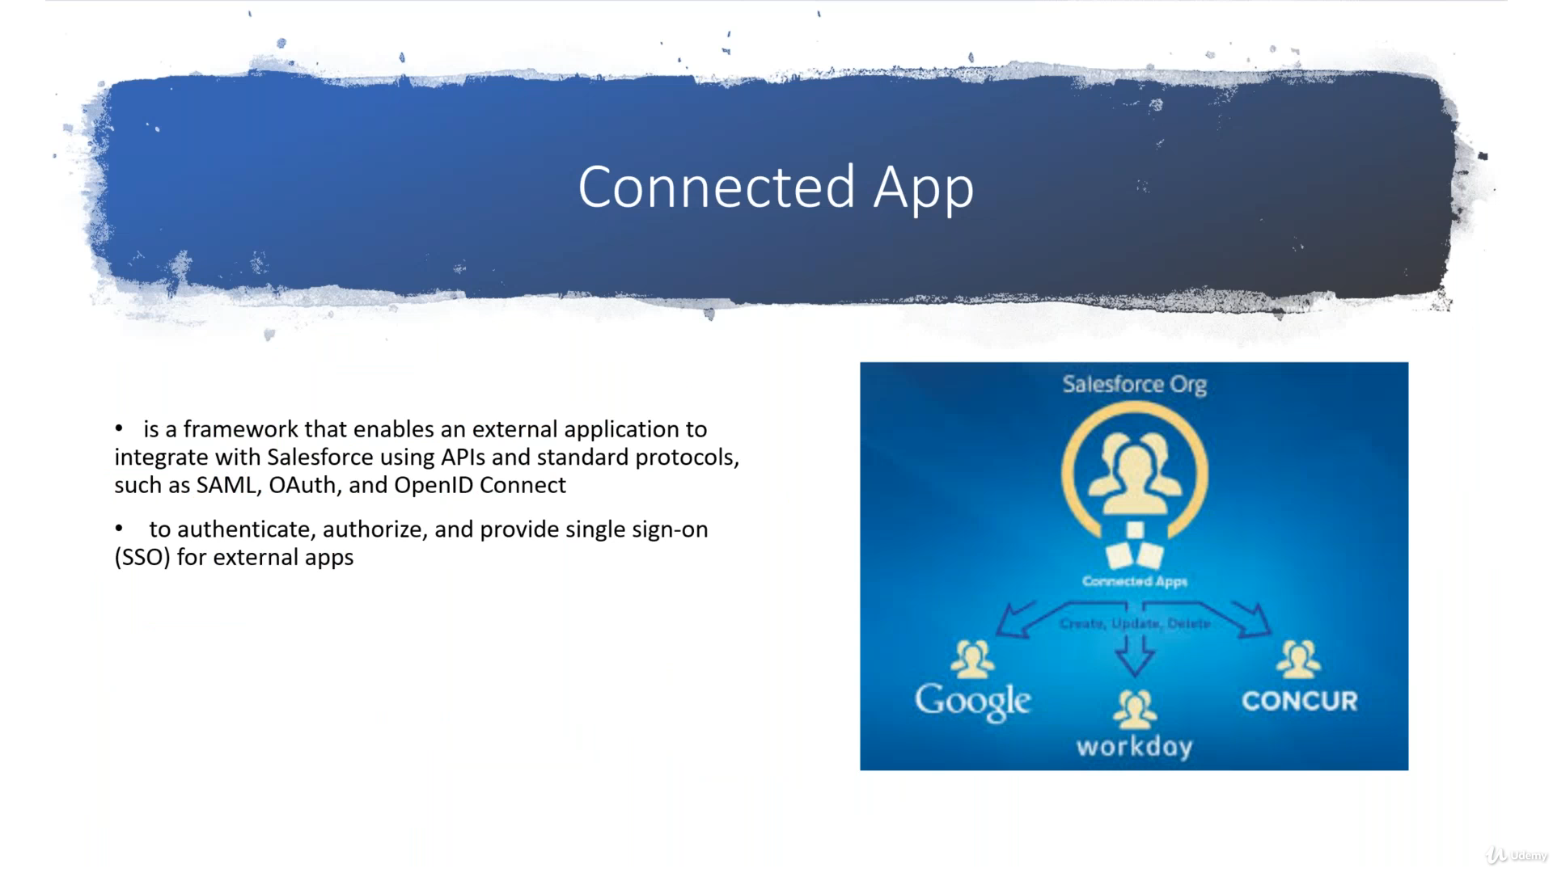

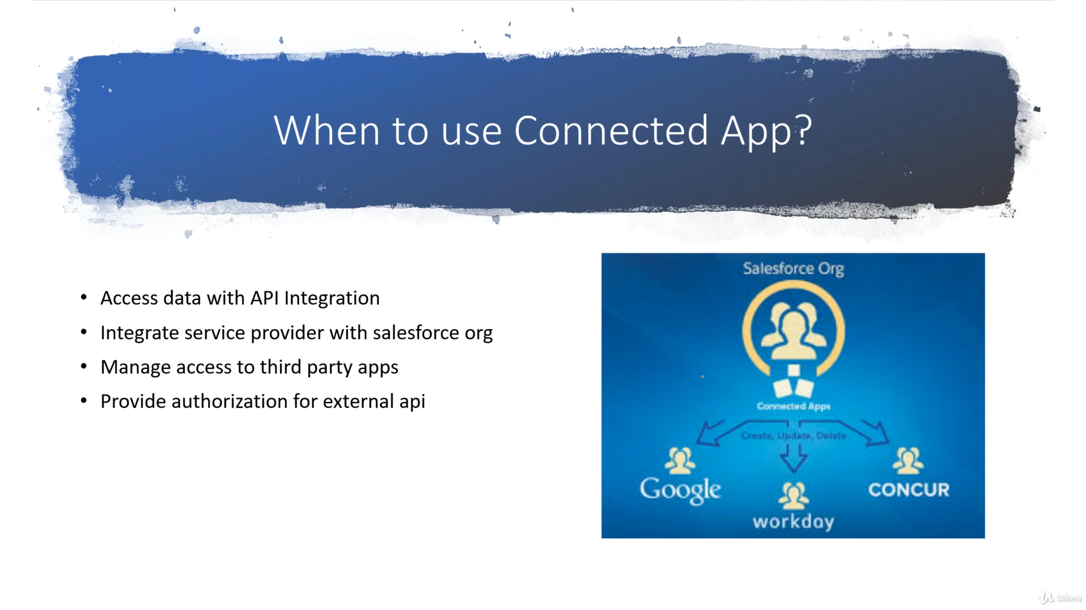

Video – 23(How to create Connected app in Salesforce):

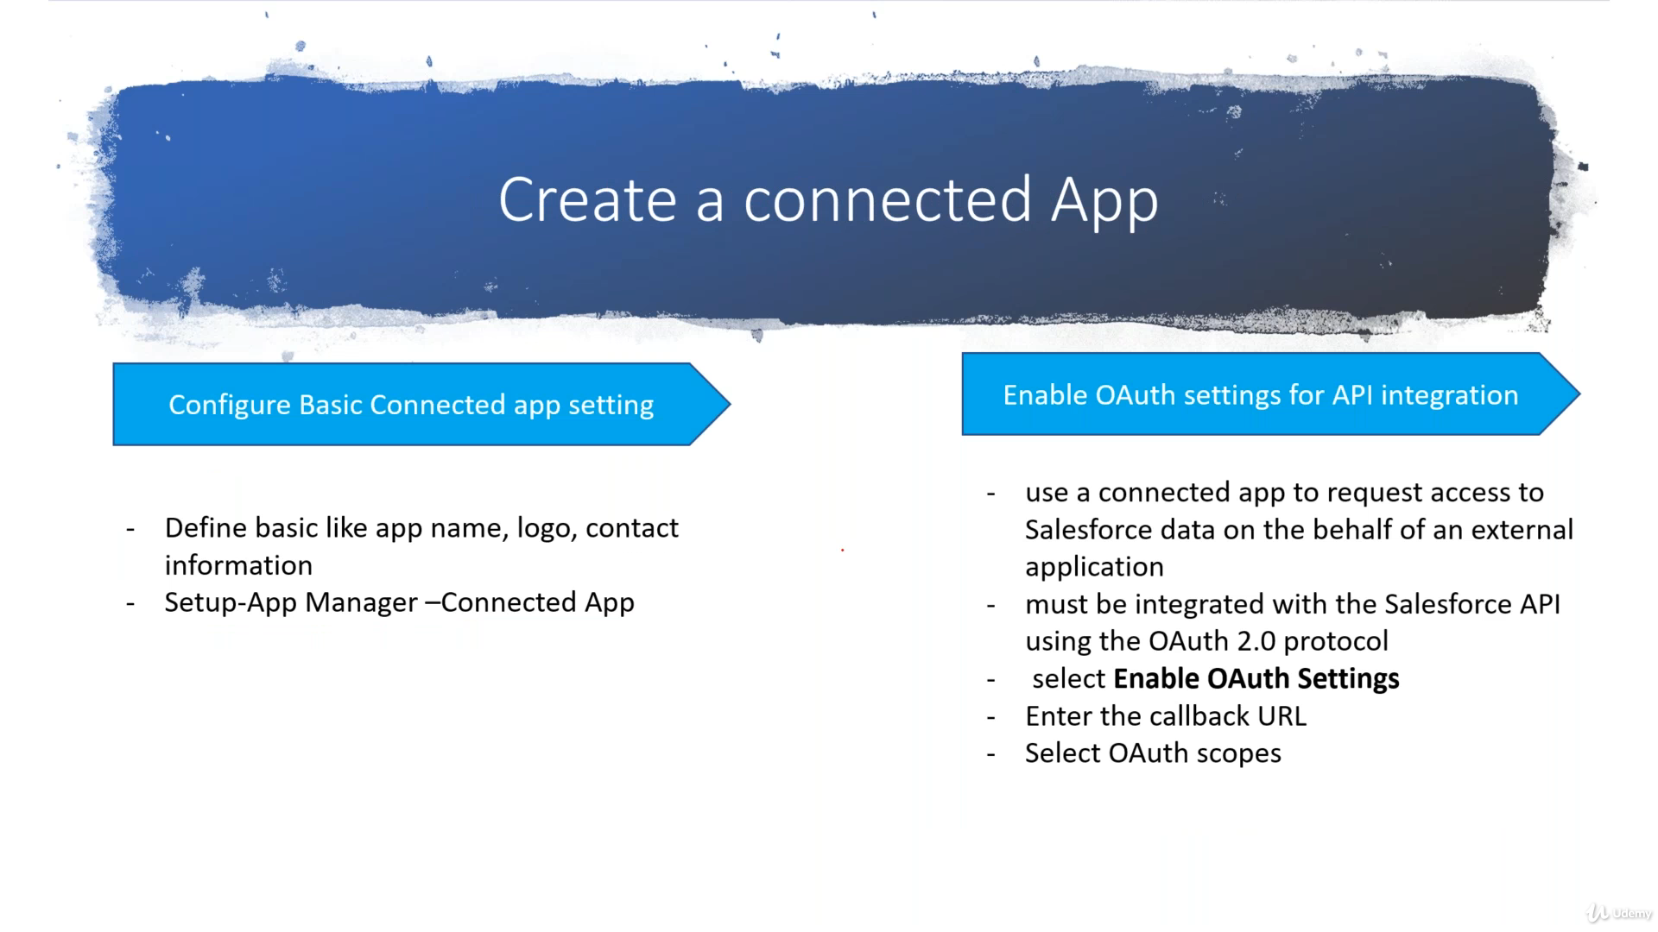

Video – 24(What is Oath in Salesforce and why do we need it?):

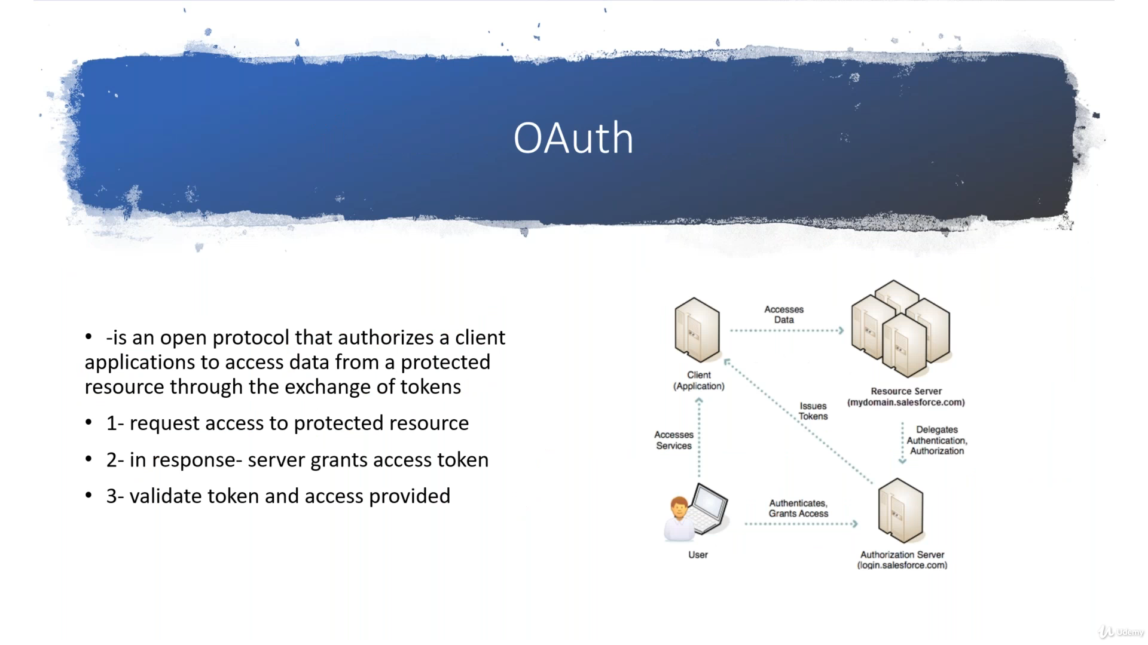

Video – 25(Different OAuth flows in Salesforce):

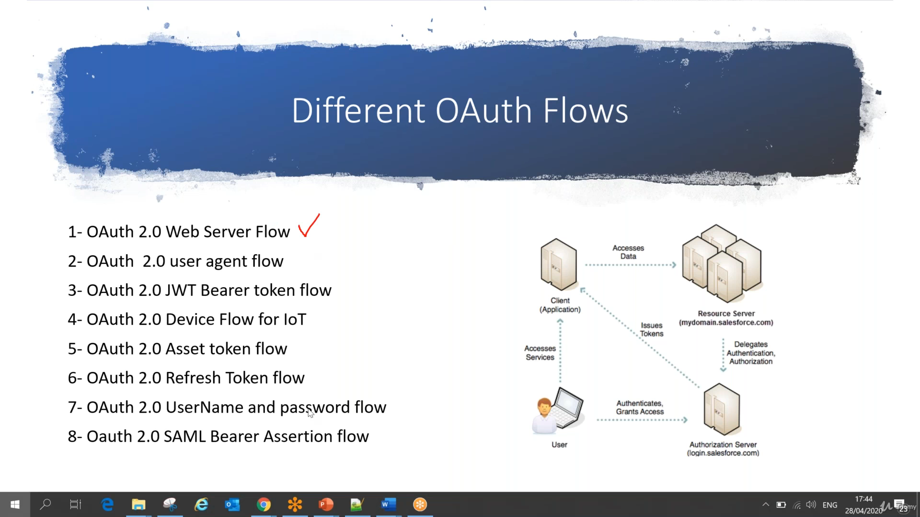

Video – 26(Use OAuth2.0 Username and Password Flow in Salesforce):

